**Breakfast Menu 2024-25 School Year**

Antietam School District

Breakfast is **FREE** to all students

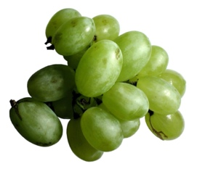  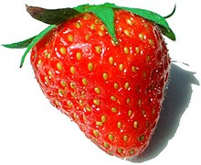

|  |  |  |  |  |  |
| --- | --- | --- | --- | --- | --- |
| Milk Served with all Meals Menu Subject to Change   |  |  |  |  |  | | --- | --- | --- | --- | --- | | Mondays  Pancakes in a Bag  100% Fruit Juice  Fruit of the Day  Choice of Milk | Tuesdays  Warm Assorted Flavored Muffin  Assorted Cereal  Fruit of the Day  Choice of Milk | Wednesdays  Bagel with  Peanut Butter or Cream Cheese Packet  100% Fruit Juice  Fruit Cup  Choice of Milk | Thursdays    Banana Bread  Cheese Stick  Fresh Fruit  Choice of Milk | Fridays    Chef Choice  Announced every  Wednesday | |

*Assorted Cereal(s) and/or Muffin(s) available as elementary alternative meal each day.

**JOIN US EACH MORNING FOR A FREE HEALTHY START TO YOUR DAY!**

 